April 15, 2020

Hi Kalfas Friends!

Miss. Brick here! How is your week going? Have you been following the 5 B’s we practice at Kalfas? It has been a fun week for me. First, I went on a walk. I felt **happy** and **refreshed** to be able to go outside. What makes you feel happy and refreshed? Then, I ate pizza for lunch! Pizza is my favorite. I felt **surprised** and **excited**! How do you feel when your family makes your favorite food for lunch? Remember, we can have many feelings at one time!

I did have one problem this week. I was building a fairy house with sticks and I was feeling **proud** because I almost finished the whole thing! That was until my brother accidently knocked it down and the sticks went everywhere! I started to feel my face get hot and red and I was feeling **annoyed** and **angry!** But then I remembered that I needed to follow the 5 B’s!

So I decided to **Stop, Step Back,** **Breathe, and Think!**

Then I realized I wasn’t feeling angry anymore because I took some deep breaths and asked my brother to help me rebuild it, together! Have you practiced how to cool down when feeling angry? Can you stop take some deep breaths and think next time you have an uncomfortable feeling?

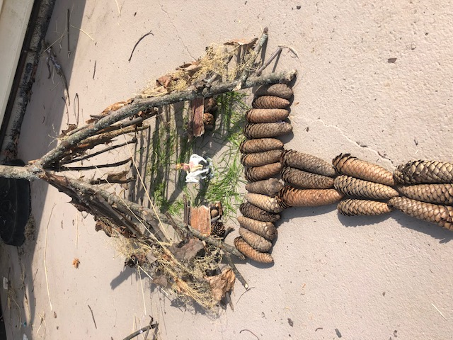

Can’t wait to talk to you again!

Miss. Brick

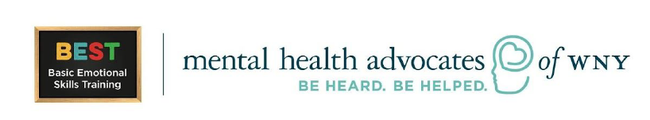

Picture of my Fairy House