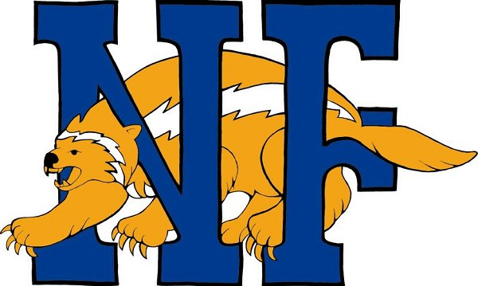 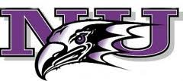

Niagara Falls City School District

Early College High School

Why Join ECHS???

* You have the opportunity to earn up to 24 college credits at no cost to you! (A value of $25,000.00)
* You will be part of a select group of students at NFHS to have this opportunity
* You will open up opportunities for yourself with college scholarships and highly acclaimed colleges and universities
* NU course credit may be transferable to other colleges and universities.
* You will receive mentoring/tutoring throughout the four year program to help you be more successful academically
* You will be able to participate in campus events at Niagara University
* Career assessments will be performed to determine your career interests
* You will take classes that will give you a solid foundation in the core curriculum areas for college entry
* You will have the opportunity to attend college classes on campus with college students at NU
* Upon registering for college courses, you will be given a Niagara University ID card so you can gain access to the Kiernan Center, library, computer labs, and other campus amenities