# Forces Driving Imperialism

The seizure of a country or territory by a stronger country is called **imperialism**. Many motives drove European imperialism during the 18th and 19th centuries. One of the chief motives was the Industrial Revolution. As European nations industrialized, they searched for new markets and raw materials to improve their economies. The race for colonies also grew out of a strong sense of national pride. Europeans viewed an empire as a measure of national greatness.

**Social Darwinism**, a theory that applied Charles Darwin's ideas about evolution and "survival of the fittest" to human society, also drove imperialism. This theory stated that those who were fittest for survival enjoyed wealth and success and were considered superior to others. The belief that one race is superior to others is called **racism.** Since non-Europeans had not made the scientific and technological progress that Europeans had, Social Darwinism considered them to be on a lower level of cultural and physical development. Consequently, Europeans had the right and the duty to bring the results of their progress to non-Europeans - what the poet Rudyard Kipling called **"The White Man's Burden."** This belief was supported by people like Cecil Rhodes, a successful businessman, who argued that the more land Britain inhabited, the better it was for the human race.

The push for expansion also came from missionaries who worked to convert the peoples of Asia, Africa, and the Pacific Islands to Christianity. Many missionaries wanted to "civilize," that is, to "Westernize," the peoples of the foreign land. They also believed that European rule was the best way to end evil practices such as the slave trade.

Britain was the first to end the slave trade. William Wilberforce led the fight in Parliament. In 1807, Parliament passed a bill to end the slave trade in the British West Indies. After he retired from Parliament in 1825, Wilberforce continued his fight to free the slaves. Britain finally abolished slavery in its empire in 1833. Other European nations and the United States also eventually outlawed slavery.

# The New Imperialism

The imperialism of the 18th and 19th centuries was conducted differently from that of the 15th and 16th centuries. In the earlier period, imperial powers often did not penetrate far into the conquered areas in Asia and Africa. Nor did they always have a substantial influence on the lives of the people. Now Europeans demanded more influence over the economic, political, and social lives of the people.

Over time, four forms of colonial control emerged: 1) colony - a country or a territory governed internally by a foreign power; 2) protectorate- a country or a territory with its own internal government but under the control of an outside power; 3) **sphere of influence**- an area in which an outside power claims exclusive investment or trading privileges; and 4) economic imperialism - independent but less developed country controlled by private business interests.

European rulers also developed two basic methods of day-to-day management: indirect control and direct control. Britain favored indirect control, which relied on local officials to handle the daily management of the colony. In addition, each colony had a legislative council that included colonial officials as well as local merchants and professionals nominated by the colonial governor. The goal was to train local leaders in the British method of government so that eventually the local population could govern itself. The French and other European powers preferred more direct control of their colonies. They developed a policy called **paternalism** in which Europeans governed people in a parental way.

**The Scramble for Africa**

The European scramble for African territory began in earnest about 1880, when the French began to expand from the West African coast toward western Sudan. With interest heightened by the discoveries of diamonds in 1867 and gold in 1886 in South Africa, no European power wanted to be left out of the race.

**The Berlin Conference** Competition was so fierce that Europeans feared war among themselves. Thus, 14 European nations met at the **Berlin Conference** in 1884-85 to lay down rules for the division of Africa. They agreed that any European country could claim land in Africa by notifying other nations of its claims and showing it could control the area. The European nations divided the continent with little thought about how African ethnic or linguistic groups were distributed. By 1914, only Liberia and Ethiopia remained free from European control.

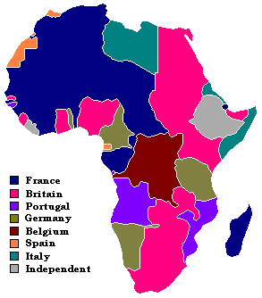

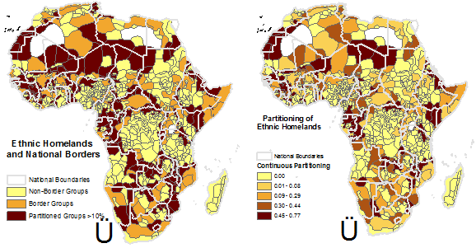

**The Boer War** The Berlin Conference did not completely eliminate conflict between the European powers. The first Europeans to settle in South Africa were the Dutch. These settlers were known as **Boers**, which is Dutch for "farmers." (The Boers are also known as Afrikaners.) When diamonds and gold were discovered in southern Africa in the 1860s and 1880s, adventurers from all parts of the world rushed in to make their fortunes. The Boers tried to keep these "outsiders" from gaining political rights. An attempt to start a rebellion against the Boers failed. The Boers blamed the British and, in 1899, took up arms against them, launching the **Boer War** (also known as the South African War). Britain eventually won the war. In 1910, the Boer republics were joined into a self- governing Union of South Africa, which was controlled by the British.

**African Resistance** Africans across the continent resisted European attempts to colonize their lands. However, the contest between African states and European powers was never equal because of the Europeans’ superior arms. In the late l800s, for instance, the Zulus lost their kingdom to the British when their spears proved no match to British guns.

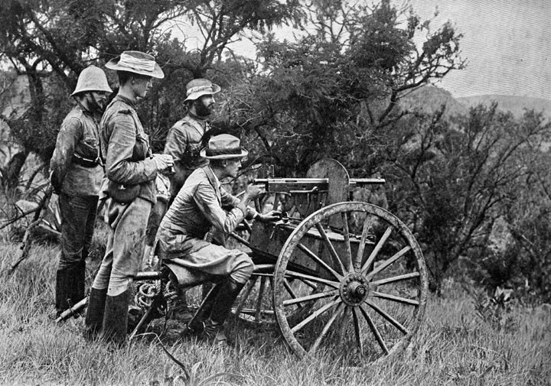 Ethiopia was the only African nation that successfully resisted the Europeans. Its victory was due to one man - **Menelik II,** who became emperor of Ethiopia in 1889. In 1896, armed with a stockpile of modern weapons purchased from France and Russia, Menelik's Ethiopian forces successfully defeated the Italians and kept their nation independent.

# The British in India https://i.gr-assets.com/images/S/compressed.photo.goodreads.com/hostedimages/1380368790i/721354.jpg

British economic interest in India began in the 1600s, when the British East India Company set up trading posts at Bombay, Madras, and Calcutta. Eventually, the East India Company governed directly or indirectly an area that included modern Bangladesh, most of southern India, and nearly all the territory along the Ganges River in the north. Officially, the British government regulated the East India Company's efforts both in London and in India. In reality, until the beginning of the 19th century the company ruled India with little interference from the British government. The company even had its own army, led by British officers and staffed by **sepoys**, or Indian soldiers.

**Britain's "Jewel in the Crown"** The Industrial Revolution had turned Britain into the world's workshop, and India was a major supplier of raw materials for that workshop. Its 300 million people were also a large potential market for British-made goods. It is not surprising, then, that the British considered India the brightest **"jewel in the crown”** - the most valuable of all its colonies.

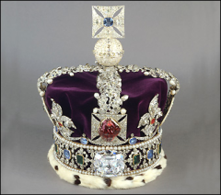

India became increasingly valuable to the British after they established a railroad network there. Railroads transported raw products from the interior to the ports and manufactured goods back again. Most of the raw materials were agricultural products produced on plantations. Plantation crops included tea, 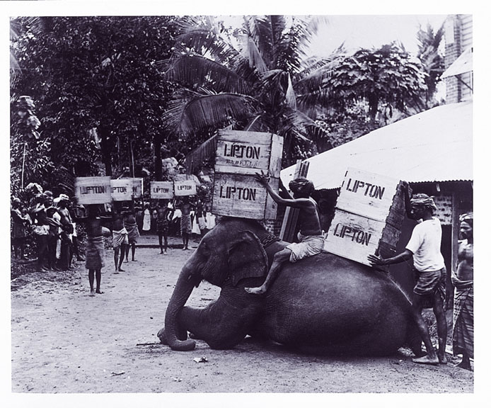 indigo, coffee, cotton, and jute. Another crop was opium. The British shipped opium to China and exchanged it for tea, which they then sold in England.

**The Sepoy Mutiny** By 1850, the British controlled most of the Indian subcontinent. However, there were many pockets of discontent. Many Indians believed that in addition to controlling their land, the British were trying to convert them to Christianity. The Indian people also resented the constant racism that the British expressed toward them. In addition, India faced mounting economic problems brought on by British control of Indian industries and the emphasis on cash crops.

As economic problems increased for Indians, so did their feelings of resentment and nationalism. In 1857, gossip spread among the sepoys that the cartridges of their new Enfield rifles were greased with beef and pork fat. To use the cartridges, soldiers had to bite off the ends. Both Hindus, who consider the cow sacred, and Muslims, who do not eat pork, were outraged by the news. A garrison commander was shocked when 85 of the 90 sepoys refused to accept the cartridges. The British handled the crisis badly. The soldiers who had disobeyed were jailed. The next day, on May 10, 1857, the sepoys rebelled. They marched to Delhi, where they were joined by Indian soldiers stationed there. They captured the city of Delhi. From Delhi, the rebellion spread to northern and central India. Some historians have called this outbreak the **Sepoy Mutiny**. The East India Company took more than a year to regain control of the country.

The mutiny marked a turning point in Indian history. As a result of the mutiny, in 1858 the British government took direct command of India. The part of India that was under direct British rule was called the Raj. The term **Raj** referred to British rule over India from 1757 until 1947. A cabinet minister in London directed policy, and a British governor-general in India carried out the government's orders. After 1877, this official held the title of viceroy.

## China

China under the Qing dynasty presented a different kind of challenge for Europeans. Out of pride for their ancient culture, the Chinese looked down on all foreigners. In addition, China was economically self-sufficient, and thus had little interest in trading with the West. For decades, the only place they would allow foreigners to do business was at the southern port of Guangzhou, (gwahng-joh). And the balance of trade at Guangzhou was clearly in China's favor. This means that China earned much more for its exports than it spent on imports. European merchants were determined to find a product the Chinese would buy in large quantities. Eventually they found one-opium.

**Opium War** Opium is a habit-forming narcotic made from the poppy plant. Chinese doctors had been using it to relieve pain for hundreds of years. In the late 18th century, however, British merchants smuggled opium into China for non-medical use. It took a few decades for opium smoking to catch on, but by 1835, as many as 12 million Chinese people were addicted to the drug.

When China's pleas to the British to stop trading in opium went unanswered, the result was the Opium War of 1839.

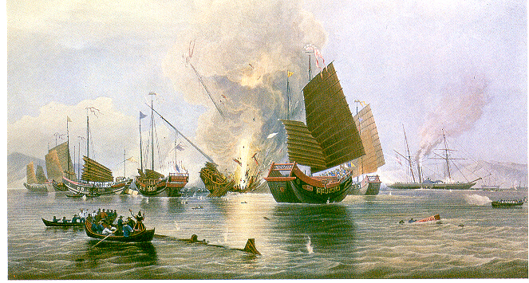The battles took place mostly at sea. China's outdated ships (known as junks) were no match for Britain's steam-powered gunboats. As a result, the Chinese suffered a humiliating defeat. In 1842, they signed the Treaty of Nanjing. This peace treaty gave Britain the island of Hong Kong (which they would control until 1997). After signing another treaty in 1844, U.S. and other foreign citizens also gained extraterritorial rights. Under **extraterritorial rights**, foreigners were not subject to Chinese law at Guangzhou and four other Chinese ports. This allowed foreign powers such as Britain, France, Germany, Russia, and Japan to develop spheres of influence in China. Many Chinese greatly resented the foreigners and the bustling trade in opium they conducted.

**Boxer Rebellion** China faced growing internal problems during the second half of the l800s. Food production could not keep up with population growth. As a result, hunger was widespread. Many people became discouraged and opium addiction rose steadily. As their problems mounted, the Chinese began to rebel against their Q’ing rulers. Throughout this period, many foreign nations took advantage of the situation and attacked China. Treaty negotiations after each conflict gave these nations increasing control over China's economy. Many of Europe's major powers and Japan gained a strong foothold in China.

Widespread frustration among the Chinese finally erupted into violence. Poor peasants and workers resented the special privileges granted to foreigners. They also resented Chinese Christians, who had adopted a foreign faith. To demonstrate their discontent, they formed a secret organization called the Society of Righteous and Harmonious Fists. They soon came to be known as the Boxers. Their campaign against the rule of China's Dowager Empress Cixi (tsoo-shee) and foreigner privilege was called the Boxer Rebellion. In the spring of1900, the Boxers descended on Beijing. Shouting "Death to the foreign devils," the Boxers surrounded the European section ofthe city. They kept it under siege for several months. The Dowager Empress expressed support for the Boxers but did not back her words with military aid. In August, a multinational force of19,000 troops marched on Beijing and quickly defeated the Boxers.

**Sun Yixian (Sun Yat-Sen) and the Revolutionary Alliance** Despite the failure ofthe Boxer Rebellion, a strong sense of nationalism had emerged in China. The Chinese people realized that their country must resist more foreign intervention and modernize. Among the groups pushing for modernization and nationalization was the **Kuomintang** (Kwoh-mihn-TANG), or the Nationalist Party. Its first great leader was **Sun Yixian** (soon yee-shyahn). In 1911, the Revolutionary Alliance, a forerunner ofthe Kuomintang, succeeded in overthrowing the last Q’ing emperor.

In 1912, Sun became president ofthe new Republic ofChina. Sun hoped toestablish a modem government based on the "Three Principles ofthe People": 1) nationalism-an end to foreign control, 2) people's rights-democracy, and 3) people's livelihood -economic security for all Chinese. Sun Yixian considered nationalism vital. Despite his lasting influence as a revolutionary leader, Sun lacked the authority and military support to secure national unity. Sun turned over the presidency to a powerful general, Yuan Shikai, who quickly betrayed the democratic ideals ofthe revolution. His actions sparked local revolts. After the general died in 1916, civil war broke out. Real authority fell into the hands ofprovincial warlords or powerful military leaders.

**Perspectives on Imperialism**

The patterns of behavior of imperialist powers were similar, no matter where their colonies were located. In some cases, the European colonial rule brought benefits, but for the most part, the effects were negative. On the negative side, Africans lost control of their land and their independence, as Europeans exploited their natural resources. Many died of new diseases such as smallpox. They also lost thousands of their people in resisting the Europeans. Famines resulted, from the change to cash crops in place of subsistence agriculture. Similarly, British restrictions on Indian-owned industries such as cotton textiles damaged these businesses. The emphasis on cash crops resulted in a loss of self-sufficiency formany villagers. As in Africa, the conversion to cash crops reduced food production, causing famines in the late 1800s. In addition, the increased presence of missionaries and the racist attitude of most British officials threatened traditional Indian life.

On the positive side, colonialism reduced local warfare in Africa. Humanitarian efforts in some colonies Improved sanitation and provided hospitals and schools. As a result, life spans increased and literacy rates improved. Also positive was the economic expansion. African products came to be valued on the international market. To aid the economic growth, railroads, dams, and telephone and telegraph lines were built in African colonies. But for the most part, these benefited only European business interests, not Africans lives. In India, the laying of the world's third largest railroad network was a major British achievement. When completed, the railroads enabled India to develop a modern economy and brought unity to the connected regions. Along with the railroads, a modem road network, telephone and telegraph lines, dams, bridges, and irrigation canals enabled India to modernize. Sanitation and public health improved. Schools and colleges were founded, and literacy increased. Also, British troops cleared central India of bandits and put an end to local warfare among competing local rulers.

For Europeans, imperialism helped lay the foundations for World War I. The quest forcolonies in Africa and Asia sometimes pushed Europeans to the brink of war. As European countries continued to compete foroverseas empires, their sense of rivalry and mistrust on one another deepened.