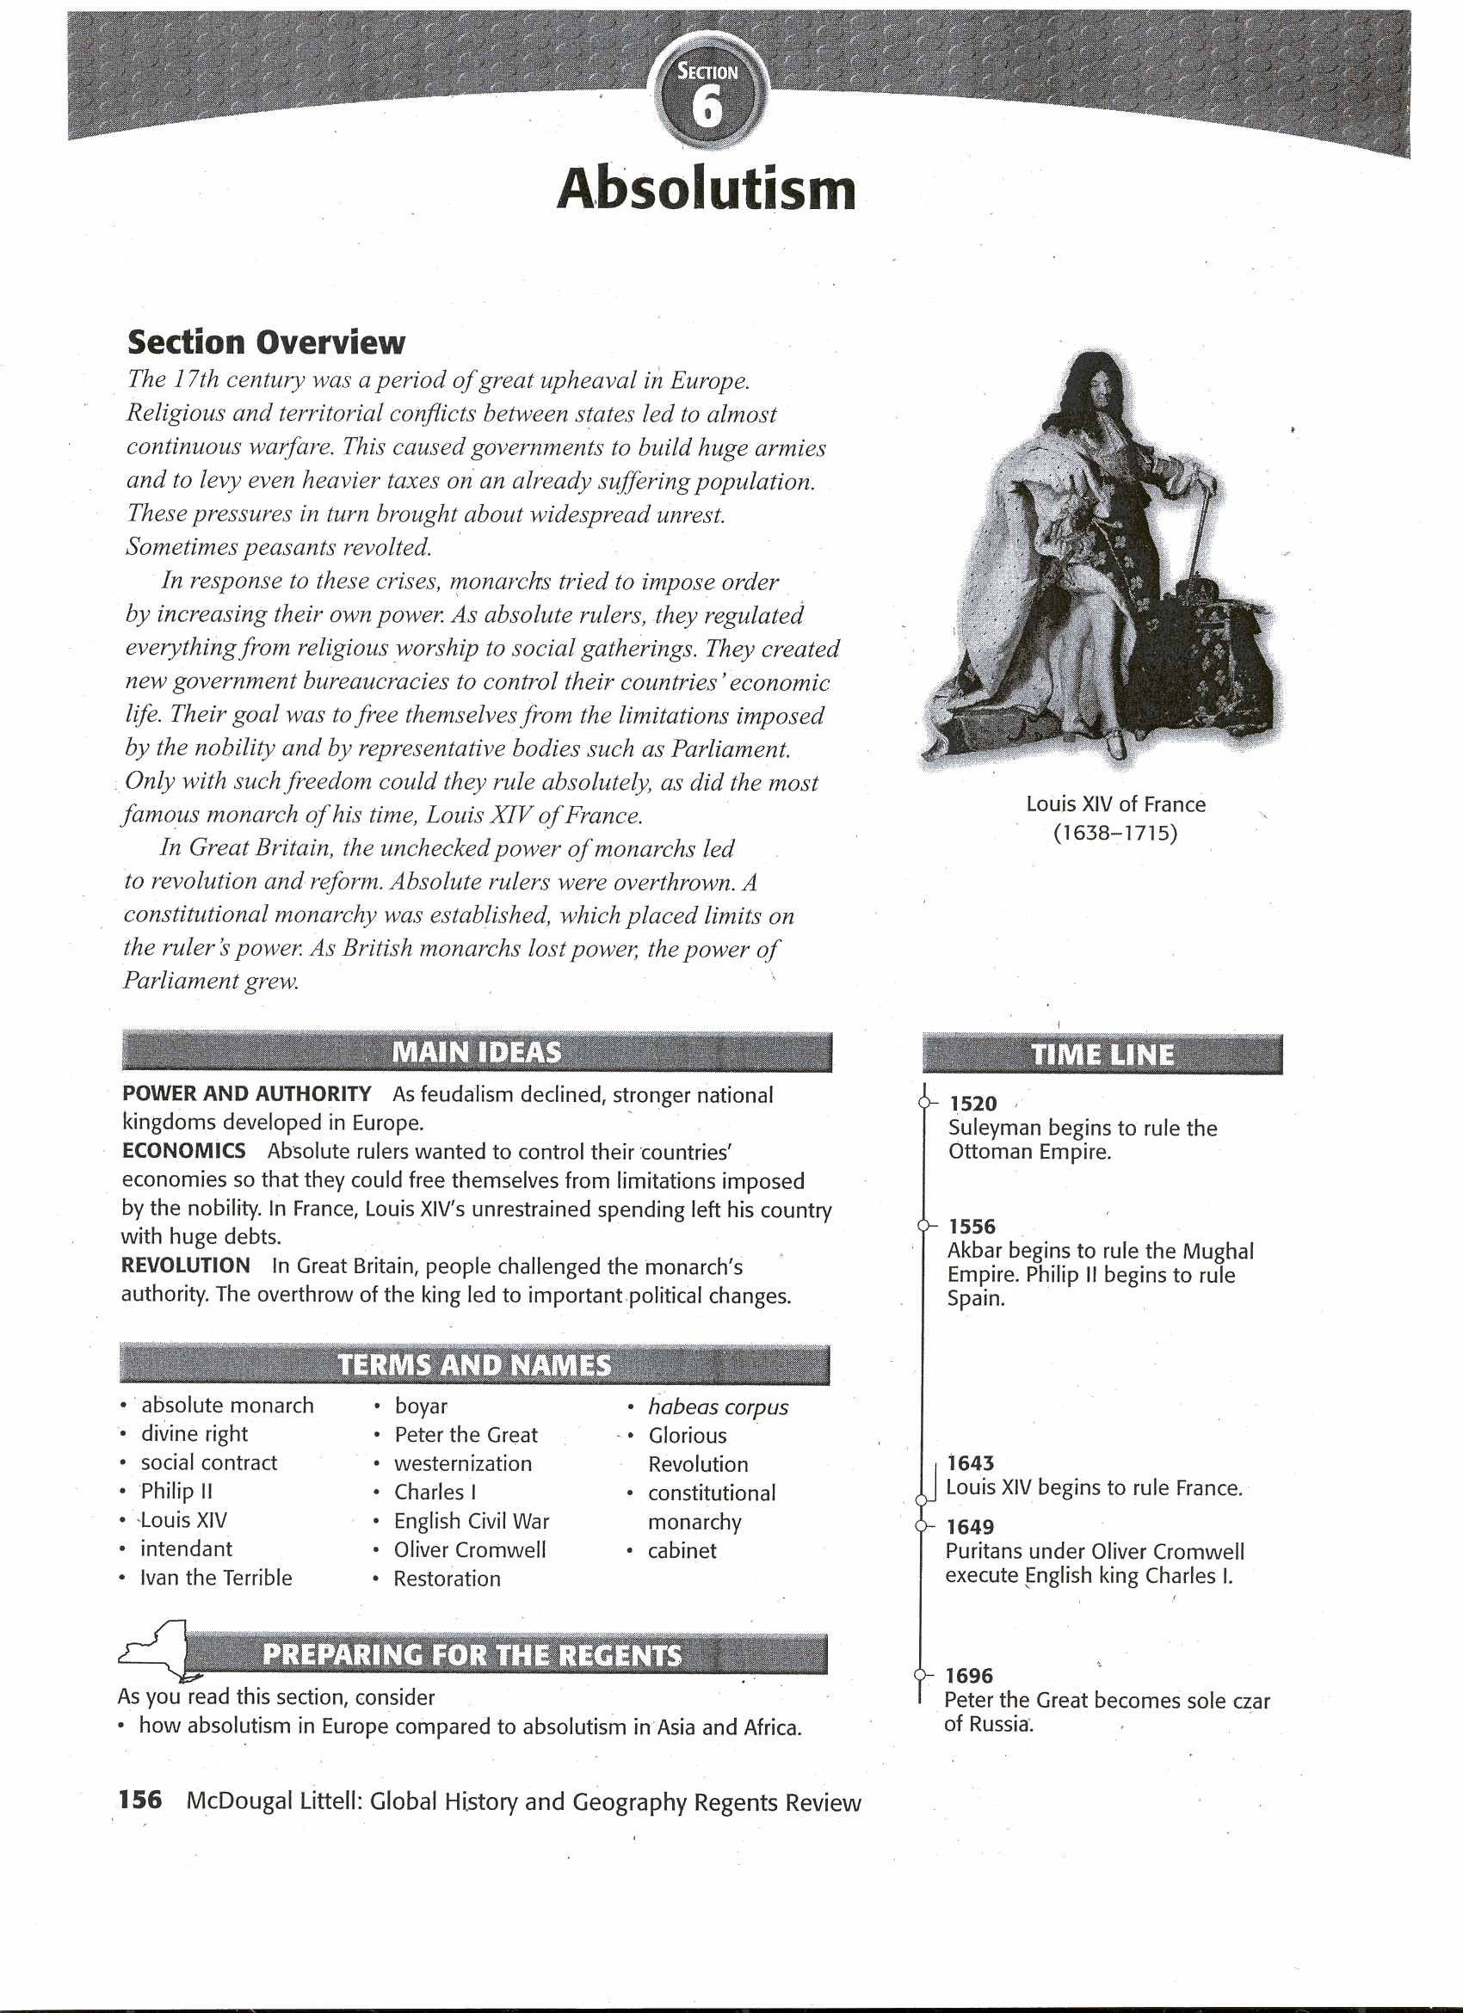

# Human and Physical Geography

As Europe emerged from the Middle Ages, monarchs grew increasingly powerful. The decline of feudalism, the weakening of Church authority, the rise of cities, and the growth of national kingdoms all helped to centralize authority. In addition, the growing middle class usually backed monarchs, because they promised a peaceful, supportive climate for business. Monarchs used the wealth of colonies to pay for their ambitions.

Crises during the 17th century further increased the power of monarchs. Religious and territorial conflicts between states led to almost continuous warfare. In response, governments built huge armies, which they paid for through heavy taxes. These pressures in turn brought about widespread unrest and sometimes even peasant revolts. Monarchs in Spain, France, Austria, England, Prussia, and Russia tried to impose order by increasing their own power. They regulated everything from religious worship to social gatherings. They created new government bureaucracies to control their countries' economic life. Their goal was to free themselves from the limitations imposed by the nobility and by representative bodies such as Parliament. These rulers wanted to be **absolute monarchs,** kingsor queens who held all of the power within their states' boundaries.

## Theories of Absolutism

The goal of absolute monarchs was to control every aspect of society. Absolute monarchs believed in **divine right,** the idea that God created the monarchy and that the monarch acted as God's representative on earth. An absolute monarch answered only to God, not to his or her subjects. One vocal supporter of this view was Jacques Bossuet (baw*soo*eh), a French bishop.

The English political thinker Thomas Hobbes also supported strong rulers. In a work called *Leviathan* (1651), Hobbes argued that without government keep order, there would be "war . . . of every man against every man," and life would be "solitary, poor, nasty, brutish, and short." To escape such a bleak life, people had to hand over their rights to a strong ruler. In exchange, they gained law and order. Hobbes called this agreement by which people created a government the **social contract.** Because people acted in their own self-interest, Hobbes said, the ruler needed total power to keep citizens under control.In Hobbes's view, such a government was an absolute monarchy.

## Absolute Rulers

Although practiced by several monarchs in Europe during the 16th through 18th centuries, absolutism has been used in many regions throughout history. In ancient times, Shi Huangdi in China, Darius in Persia, and the Roman caesars were all absolute rulers. As you have already learned, from 1520 to 1566, Suleyman I exercised great power as sultan of the Ottoman Empire. Similarly, Akbar, who ruled the Mughal Empire in India from 1556 to 1605, also held great power. Among European monarchs of the same time period, the Hapsburg king Charles V ruled with almost as much power. When his son, **Philip II** came to power in 1556, he continued to rule with a strong hand.

**Philip II** Charles V divided his vast empire between his brother Ferdinand, and Philip. Philip received Spain, the Spanish Netherlands, and the American colonies. In 1580, he added Portugal with all of its possessions. Philip’s empire provided him with incredible wealth. With this wealth, Spain was able to support a large standing army of about 50,000 soldiers.

When Philip assumed the throne, Europe was experiencing religious wars caused by the Reformation. Philip believed it was his duty to defend Catholicism against the Muslims of the Ottoman Empire and the Protestants of Europe. In 1571, he battled a large Ottoman fleet in a fierce battle near Lepanto and won. He was not as lucky against the Protestants. In 1588, Philip launched the Spanish Armada in an attempt to punish Protestant England and its queen, Elizabeth I, who had supported Protestant subjects who had rebelled, against Philip. However, his fleet was defeated. He also failed in his attempts to bring the Protestants in the Spanish Netherlands under control. In 1579, the seven northern provinces of the Netherlands, which were largely Protestant, united and declared their independence from Spain. They became the United Provinces of the Netherlands. The ten southern provinces (present-day Belgium) were Catholic and remained under Spanish control.

**Louis XIV** Even though Philip II lost his Dutch possessions, he was a forceful ruler in many ways. He tried to control every aspect of his empire's affairs. **Louis XIV,** who ruled France from 1643 to 1715, was even more forceful. In Louis's view, he and the state were one and the same. He reportedly boasted, "'L' etat, c' est moi," meaning, "I am the state."

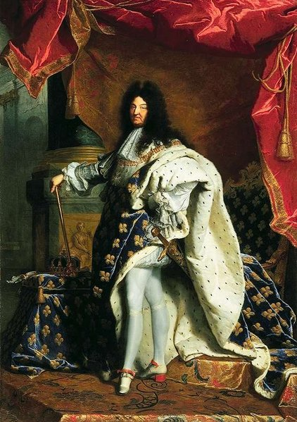

Although Louis XIV became the strongest king of his time, he was only a four-year-old boy when he began his reign. The true ruler of the country was Cardinal Mazarin (MAZ*uh*RAN). Many people in France, particularly the nobles, hated Mazarin because he increased taxes and strengthened the central government. From 1648 to 1653, violent anti-Mazarin riots tore France apart. At times, the nobles who led the riots threatened the young king's life. Even after the violence was over Louis never forgot his fear or his anger at the nobility. He was determined to become so strong that they could never threaten him again.

When Cardinal Mazarin died in 1661, the 22-year-old Louis took control of the government himself. He weakened the power of the nobles by excluding them from his councils. In contrast, he increased the power of the government agents called intendants, who collected taxes and administered justice. To keep power under central control, he regularly communicated with local officials.

**Ivan the Terrible** Ivan I, called Ivan the Terrible, came to the throne of Russia in 1533 when he was only three years old. His young life was disrupted by struggles for power among Russia's landowning nobles, known as **boyars**. The boyars fought to control young Ivan. When he was 16, Ivan seized power and had himself crowned czar. This title meant "caesar," and Ivan was the first Russian ruler to use it officially.

The years from 1547 to 1560 are often called Ivan's "good period." He won great victories, added lands to Russia, gave Russia a code of laws, and ruled justly. Ivan's "bad period" began in 1560 after his wife, Anastasia, died. Accusing the boyars of poisoning his wife, Ivan turned against them. He organized his own police force, whose chief duty was to hunt down and murder people Ivan considered traitors. Using these secret police, Ivan executed many boyars, their families, and the peasants who worked their lands. Thousands of people died. Ivan seized the boyars' estates and gave them to a new class of nobles, who had to remain loyal to him or lose their land.

Following the death of Ivan and then his son, Russia experienced a period of turmoil known as the Time of Troubles. Finally, in 1613, representatives from many Russian cities met to choose the next czar. Their choice was Michael Romanov, grandnephew of Ivan the Terrible's wife, Anastasia.

**Peter the Great** Over time the Romanovs restored order to Russia. They strengthened government by passing a law code and putting down a revolt. This paved the way for the absolute rule of Czar Peter I. At first, Peter shared the throne with his half-brother. However, in 1696, Peter became sole ruler of Russia. He is known to history as **Peter the Great**, because he was one of Russia's greatest reformers. He also continued the trend of increasing the czar's power.

When Peter I came to power, Russia was still a land of boyars and serfs. Serfdom in Russia lasted into the mid-1800s, much longer than it did in Western Europe. Most boyars knew little of Western Europe. In the Middle Ages, Russia had looked to Constantinople, not to Rome, for leadership. Then Mongol rule had cut Russia off from the Renaissance and the Age of Exploration. Geographic barriers also isolated Russia. Its only seaport, Archangel in northern Russia, was choked with ice much of the year.

Peter was 24 years old when he became the sole ruler of Russia. In 1697, just one year later, he embarked on the "Grand Embassy," a long visit to Western Europe. One of Peter's goals was to learn about European customs and manufacturing techniques. Inspired by his trip to the West, Peter resolved that Russia would compete with Europe on both military and commercial terms. Peter's goal of **westernization**, of using Western Europe as a model for change, was not an end in itself. Peter saw it as a way to make Russia stronger.

Although Peter believed Russia needed to change, he knew that many of his people disagreed. To force change upon his state, Peter increased his powers as an absolute ruler. Peter brought the Russian Orthodox Church under state control. He abolished the office of patriarch, head of the Church. He set up a group called the Holy Synod to run the Church under his direction. Like Ivan the Terrible, Peter reduced the power of the great landowners. He recruited men from lower-ranking families. He then promoted them to positions of authority and rewarded them with grants of land. Peter also hired European officers to help him modernize the army. By the time of Peter's death, the Russian army numbered 200,000 men. To pay for this huge army, Peter imposed heavy taxes.

Peter also instituted many reforms, however. He introduced potatoes into the Russia diet, started Russia's first newspaper, raised the status of women, ordered nobles to wear western clothes, and improved education. In addition, Peter built a new seaport city - St. Petersburg - on the Baltic coast on land won from Sweden. From St. Petersburg, ships could sail down the Neva River into the Baltic Sea and on to Western Europe. 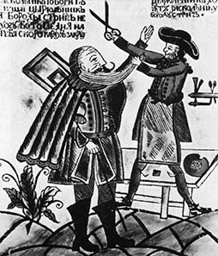

### Responses to Absolutism in England

During her reign, Queen Elizabeth I of England had frequent conflicts Parliament. Many of the arguments were over money, because the treasury did not have enough funds to pay the queen's expenses. By the time Elizabeth died in 1603, she had left a huge debt for her successor to deal with. Parliament's financial power was one obstacle to English rulers' becoming absolute monarchs. The resulting struggle between Parliament and the monarchy would have serious consequences for England.

**The Stuarts and the Divine Right of Monarchy** Elizabeth had no child, and her nearest relative was her cousin, James Stuart. Already king of Scotland, James Stuart became King James I of England in 1603. James inherited the unsettled issues of Elizabeth's reign. His worst struggles with Parliament were over money and his refusal to reform the English church.

In 1625, James I died. **Charles I,** his son, took the throne. Charles always needed money, in part because he was at war with both Spain and France. Several times when Parliament refused to give him funds, he dissolved it. By 1628, Charles was forced to call Parliament again. This time it refused to grant him any money until he signed a document that is known as the Petition of Right. In this petition, the king agreed to four points: 1) He would not imprison subjects without due cause. 2) He would not levy taxes without Parliament's consent. 3) He would not house soldiers in private homes. 4) He would not impose martial law in peacetime. After agreeing to the petition, Charles ignored it. Even so, the petition was important. It set forth the idea that the law was higher than the king. This idea contradicted theories of absolute monarchy. In 1629, Charles I dissolved Parliament and refused to call it back into session.

**Oliver Cromwell-the English Civil War** Charles offended Puritans by upholding the rituals of the Anglican Church. In addition, in 1637, Charles tried to force the Presbyterian Scots to accept a version of the Anglican prayer book. He wanted both his kingdoms to follow one religion. The Scots rebelled, assembled a huge army, and threatened to invade England. To meet this danger, Charles needed money - money he could get only by calling Parliament into session. This gave Parliament a chance to oppose him.

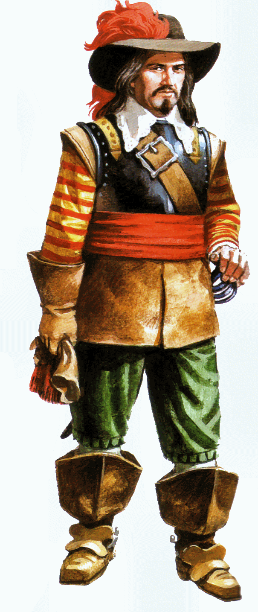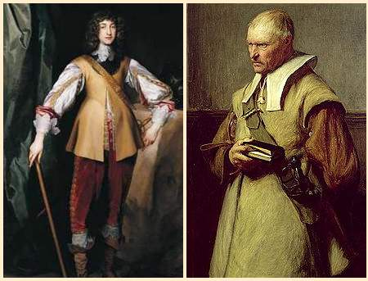

During the autumn of 1641, Parliament passed laws to limit royal power. Furious, Charles tried to arrest Parliament's leaders in January 1642, but they escaped. Equally furious, a mob of Londoners raged outside the palace. Charles fled London and raised an army in the north of England, where people were loyal to him. From 1642 to 1649, supporters and opponents of King Charles fought the **English Civil War.** At first neither side could gain a lasting advantage. The tide turned in favor of the Puritans when **Oliver Cromwell** became their general.

In 1649, the Puritans brought Charles to trial for treason against Parliament. They found him guilty and sentenced him to death. His execution was revolutionary. Never before had a reigning monarch faced a public trial and execution.

Cromwell now held the reins of power. In 1649, he abolished the monarchy and the House of Lords. He established a commonwealth, a republican form of government. In 1653, Cromwell sent home the remaining members of Parliament. Cromwell's associate John Lambert drafted a constitution, the first written constitution of any modem European state. However, Cromwell eventually tore up the document and became a military dictator.

**The Glorious Revolution** Cromwell ruled until his death in 1658. Shortly afterward, the government he had established collapsed, and a new Parliament was selected. In 1659, Parliament voted to ask Charles II, the older son of Charles I, to rule England. Because he restored the monarchy, the period of Charles II's rule is called the **Restoration**.

During Charles II's reign, Parliament passed an important guarantee of freedom, ***habeas corpus.*** *Habeas corpus* is Latin meaning "to have the body." This 1679 law gave every prisoner the right to obtain a writ or document ordering that the prisoner be brought before a judge to specify the charges against the prisoner. The judge would decide whether the prisoner should be tried or set free. Because of the Habeas Corpus Act, a monarch could not put someone in jail simply for opposing the ruler, and prisoners could not be held indefinitely without trials.

In addition, Parliament debated who should inherit Charles's throne. Charles's heir was his brother James, who was Catholic. When Charles died in 1685, James II became king. James soon offended his subjects by displaying his Catholicism. Violating English law, he appointed several Catholics to high office. When Parliament protested, James dissolved it. In 1688, James's second wife gave birth to a son. English Protestants were terrified at the prospect of a line of Catholic kings.

James had an older daughter, Mary, who was Protestant. She was also the wife of William of Orange, a prince of the Netherlands. Seven members of Parliament invited William and Mary to overthrow James for the sake of Protestantism, When William led his army to London in 1688, James fled to France. This bloodless overthrow of King James II is called the **Glorious Revolution.**

**The English Bill of Rights** At their coronation, William and Mary vowed to recognize Parliament as their partner in governing. England had become not an absolute monarchy but a **constitutional monarchy**, where laws limited the ruler’s power. To make clear the limits of royal power, Parliament drafted a Bill of Rights in 1689 building on the democratic principles first outlined in the Magna Carta, this document listed many things that a ruler could not do. For example a ruler could not suspend Parliament’s laws, levy taxes without a specific grant from Parliament, interfere with freedom of speech in Parliament or penalize a citizen who petitions the king about grievances. William and Mary consented to these and other limits on their royal power.

After 1688, no British monarch could rule without the consent of Parliament. At the same time, Parliament could not rule without the consent of the monarch. If the two disagreed government came to a standstill. During the 1700s, this potential problem was remedied by the development of a group of government ministers, or officials, called the **cabinet.** These ministers acted in the ruler's name but in reality represented the major party of Parliament. Therefore, they became the link between the monarch and the majority party in Parliament.