

Incident IQ, iiQ, is the system used to enter tickets for technology assistance in the Niagara Falls City School district. All employees at NFCSD will use iiQ. *Students WILL NOT use at this time*.

Go to **nfschools.incidentiq.com**

# Login to iiQ

At the login screen, you will need to click Microsoft AZURE icon. If it prompts you for a Username and password it will be the same as you use for other district software (Mail, teams, Clever)

Username: **mcacciatore@nfschools.net**

Password: **computer login password**

# 

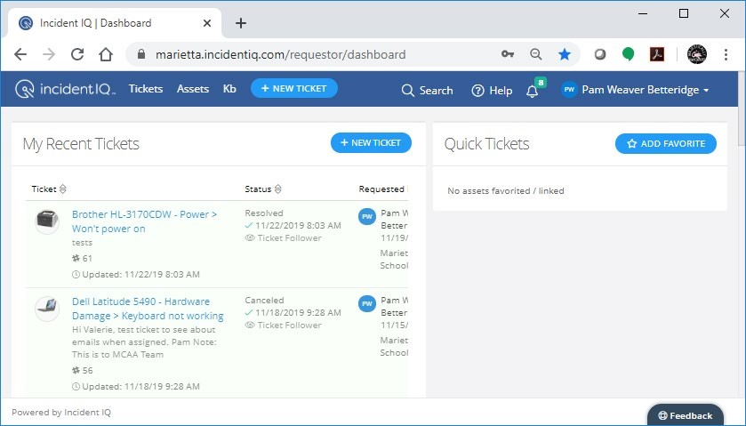

Your iiQ Dashboard opens.

This is where you enter tickets, view current/past tickets, view information in the Kb, Knowledge base and at a future date, view the technology assets assigned to you/classroom.

Click on + NEW TICKET to enter your issue.

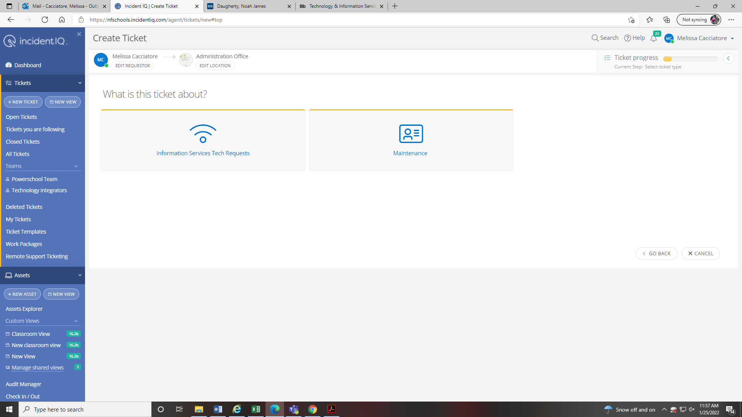

**New Ticket Screen information**

**Requester**

* Requestor defaults to you. Notice you are able to Edit Requestor. Use this option if you need to enter a ticket for someone else. Find that user in the list.
* Your account is already located at your designated work location. The location can be changed if you are at another site needing assistance. Central Staff, please be aware of your location and update it as needed.
* Ticket progress shows you what point you are in the ticket process. You can click the < arrow to go back to the previous screen/

**What is this ticket about**

* Categories on for the issue you are experiencing. Click on each button and you will see the additional break

**Example of entering a Device Issue request**

Click on Information Services Tech request (shown on the New Ticket picture above)

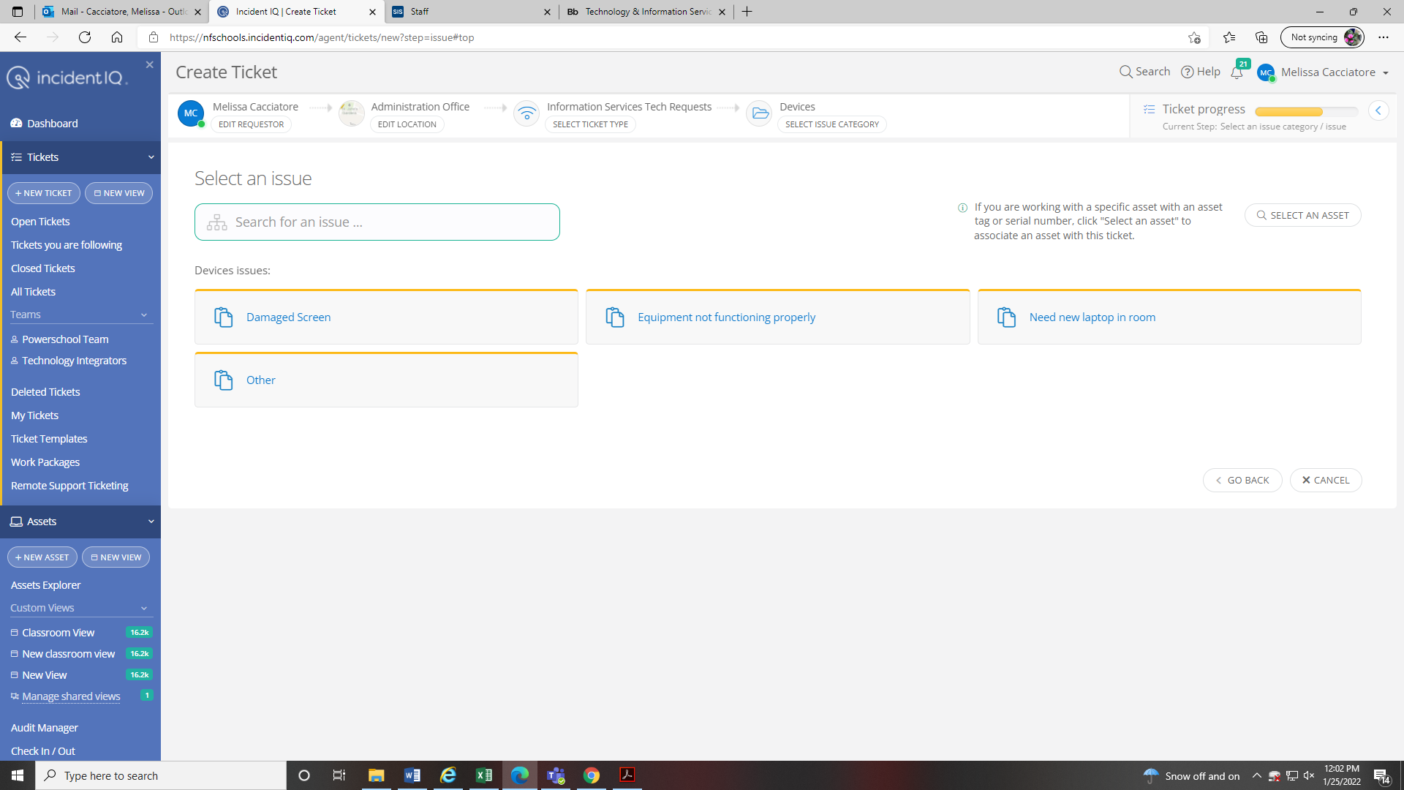

Select the category of your issue

The full ticket screen is shown to the right.

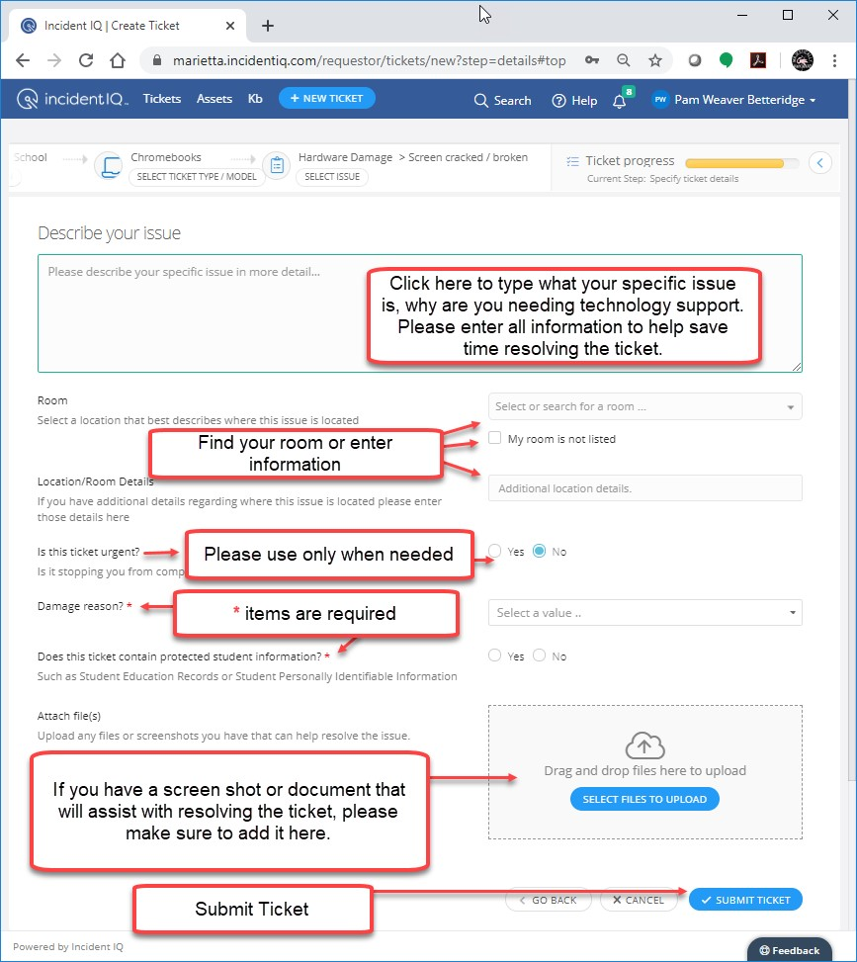

After submitting ticket, you return to your dashboard with the ticket # and summary of your ticket.

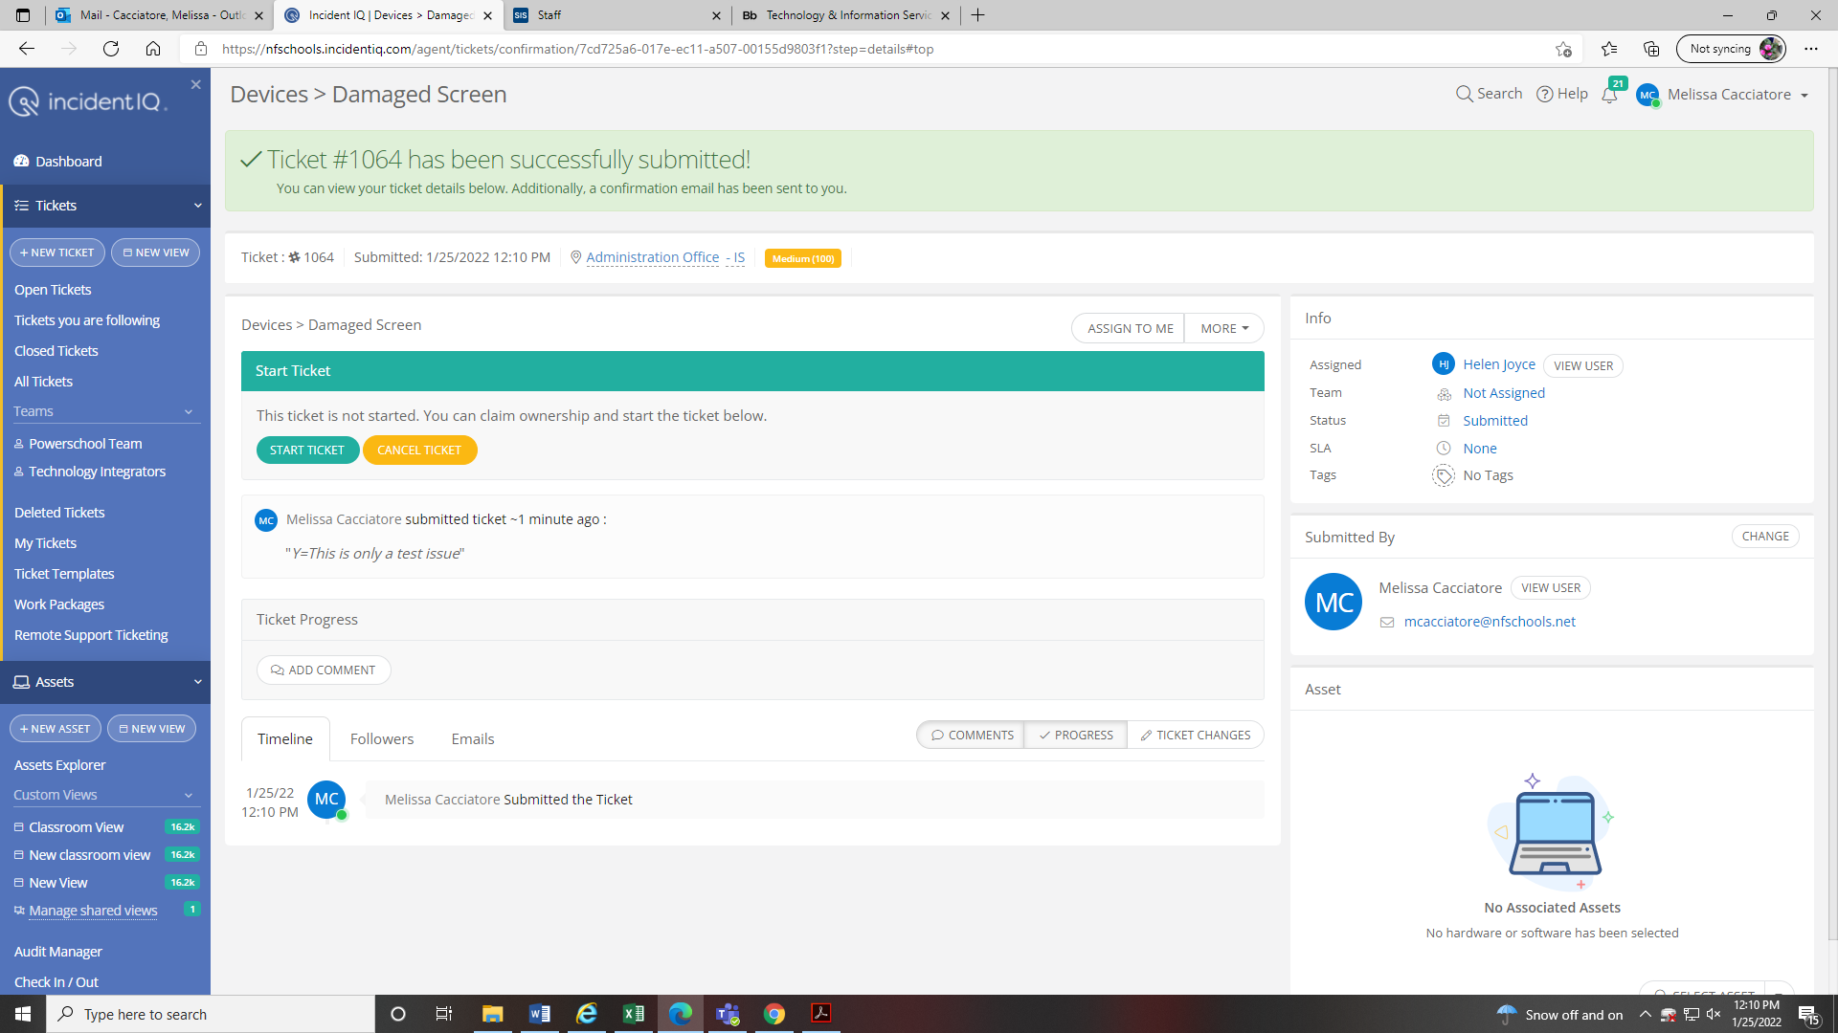

You will also receive an email with the ticket information.

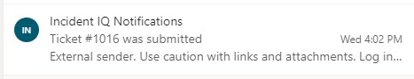

Once your ticket is assigned to a Technology Support Staff member, you will receive another email.

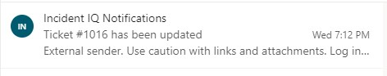

You are able to open the ticket to see progress as well as add additional information/comments as needed.