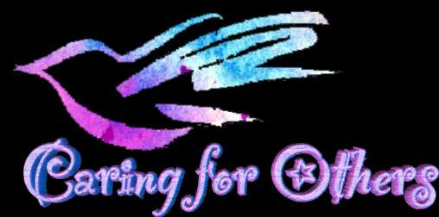

Please join us in a District Wide Initiative as we kick off our **Cards for Caring Campaign.** The Schoellkopf Nursing Home currently has 107 patients. We are asking District employees and their families to send cards, drawings, pictures or stories to a resident. Along with your well wishes, do not be afraid to tell them all about you and your family. Reassure them that things will get better.

Address your cards to:

A Resident of the Schoellkopf Health Facility

621 10th Street

Niagara Falls New York 14302

A drop box is located in the front of NFMMC if you prefer to send something this way.

Judy Villani the Director of Volunteers will give Community Service Hours to high school students and a certificate to elementary students for their participation. More importantly, we will ALL be given the satisfaction of helping others.

Feel free to include an email address or home address in your correspondence. They may want to write back! I know they will all be anxious to hear from all of us.

Any questions or concerns email [Aorfano@nfschools.net](mailto:Aorfano@nfschools.net) or contact Judy Villani at volunteers @nfmmc.org