Example 1: Morning Routine
Wake Up ex. 9:00am | Set a wake up time. This should stay the same.
Get Ready ex. 9:15am  15 minutes | This should include going to the bathroom, brushing hair and teeth and getting dressed.
Exercise ex. 9:30am  15 minutes | Visit Miss. Brick’s Webpage for Movement Breaks/Yoga links.
Breakfast  ex. 9:45am  15 minutes | Can get from local school.
School Work  ex. 10:45am  1 hour | Visit teacher’s Webpage for ideas.
Craft  ex. 11:45am  1 hour | Can include coloring, painting, drawing, playduh or a planned craft. Please visit Miss. Brick’s Webpage for crafts.
Afternoon Routine
Lunch  ex. 12:15pm  30 minutes | Can get from local school.
Meditation  ex. 12:30pm  15 minutes | Go to Miss. Brick’s Webpage to complete daily activities.  Visit the Resource Guide on her Webpage for Meditation Apps.
Quiet Time  ex. 1pm  30 minutes | This can include a nap or read books.
School Work  Ex. 2pm  1 hour | Go to teacher’s Webpage for ideas.
Free Time  ex. 4pm  2 hours | This can include play time with toys or time in the backyard on a nice day.
Evening Routine
Dinner  ex. 4:30pm  30 minutes | If you need food, visit the Resource Guide on Miss. Brick’s Webpage for food pantries.
Puzzles/Games  ex. 5:30pm  1 hour | This can include floor puzzles, board games, activity books with mazes, etc.
Family Movie  Ex 7pm  1.5 hours | Time with family doing an activity together.
Get Ready for Bed  ex. 7:30pm  30 minutes | This should include a bath, going to the bathroom, brushing teeth and getting on pjs.
Story Time  ex. 7:40pm  10 minutes | Have child pick a story for you to read them.
Goodnight  ex. 7:45pm | Set a bedtime. This should stay the same.
Once task is complete you can put a sticker/star/smiley in the box. Set goals and rewards for stickers/star/smiley received. Start with small goals.
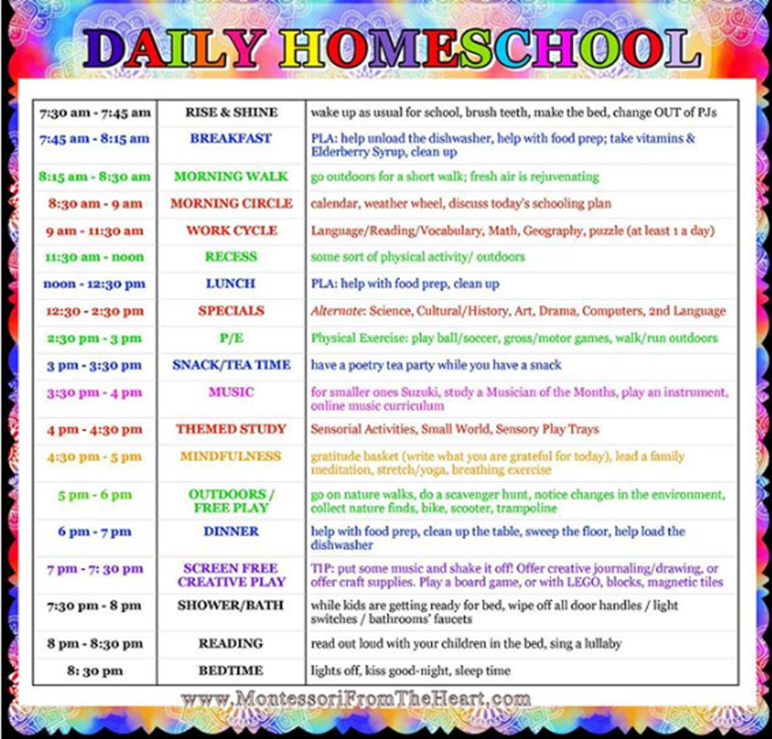
Example 2:

