Primary Source Activity
GROWTH AND EXPANSION
Lesson 3: Unity and Sectionalism
Why We Need a Protective Tariff
Before the War of 1812, the United States was dependent on other countries, especially Great Britain, for manufactured goods. The war cut off the supply of British goods and helped stimulate American manufacturing. After the war, the British again began offering inexpensive manufactured goods. As a result, new American companies cried out for protection against European competition. The following newspaper editorial from the Niles Weekly Register supports a protective tariff and predicts what will happen to American factories without tariff protection.
DIRECTIONS: Read the editorial and answer the questions that follow.
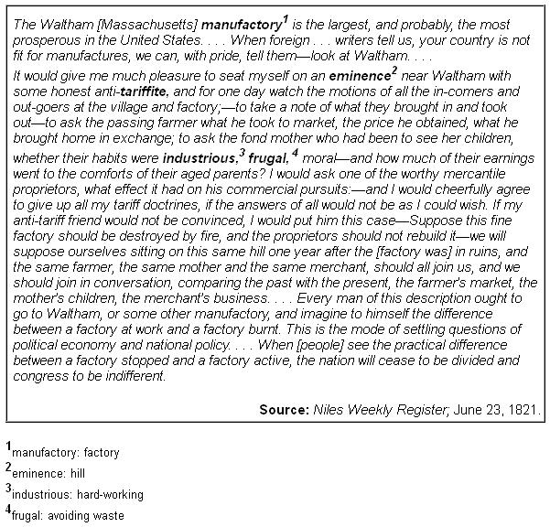

1. Analyzing Primary Sources
Identifying In what ways does the author show how a protective tariff will benefit people in his town?

2. Analyzing Primary Sources
Expressing How does the author illustrate that the town would be negatively affected if the factory were to close?

3. Analyzing Primary Sources
Describing According to the editorial, what is the proper method for settling questions of economic and national policy?

4. Analyzing Primary Sources
Making Connections Why might a modern autoworker employed by an American manufacturer favor a protective tariff today? Why might American consumers oppose such a tariff?

5. Critical Thinking
Making Inferences What is the purpose of the author’s opening paragraph?

