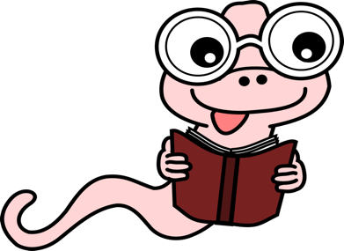**School Library**

**Directions for reading books online and other resources**

* There are 2 ways to get to your school library page all from [www.nfschools.net](http://www.nfschools.net)

1. Click the library icon on your school’s [Symboloo](http://library.nfschools.net/) page.
2. Go to the bottom right of any page on the district webpage. Click on [*Visit your school library*](http://library.nfschools.net/)

* Find your school and click on it
* The directions to read books online are written at the top of the library page in the blue box. They are also below.

To read 1000’s of books online Click on the **Learning links** on library webpage.

These two sites will need this login information all others you can just click on and they will take you to the site.

* **MyOn**: School Name: New York Reads. Username: read Password: books
* Worldbook: Username: **niagara** Password: **falls. Tons of activities and online books to read.**

**﻿**

**ebooks:** some may need this: **Username & Password is onboces** or you may have to use your school network login which is what you do when you login at school.

Explore these resources and enjoy!

If you are having trouble email lmoskaluk@nfschools.net with questions